Reading 2：**[The Museum of Us](http://nceonline.zju.edu.cn/new/books/book4/cached_general/u7_in_class_reading.htm" \l "null)**

1. He picked up a letter that he had carefully ***tucked（把…放起来）*** under a pile of letters on the desk.

（VERB) 把…塞入;把…藏入 If you tuck something somewhere, you put it there so that it is safe, comfortable, or neat.

● He tried to tuck his flapping shirt inside his trousers... 他设法把飘起的衬衫塞到裤子里。

She found a rose tucked under the windscreen wiper of her car one morning.

一天清晨，她发现自己汽车的挡风玻璃雨刷下插着一支玫瑰。

She ***tucked up her skirt*** and waded into the river. 她撩起裙子蹚水走进河里。

The sheets should ***be tucked in*** neatly (= around the bed) . 床单的四边应整整齐齐地掖在褥垫下面。

Tuck the flap of the envelope in. 把信封的口盖塞进信封里。

She ***tucked her hair (up)*** under her cap. 她把头发拢起来塞进帽子里。

He sat with his legs tucked up under him. 他盘着腿坐着。

The letter had been tucked under a pile of papers.那封信压在了一摞文件下面。

She tucked a blanket around his legs. 她拿一条毯子把他的双腿裹好。

造句：

1. Amy Johnson was a pioneering ***aviator（飞行员; 飞机驾驶员）；*** who made record-breaking flights to Australia and South Africa in the 1930s. (aviatrix)

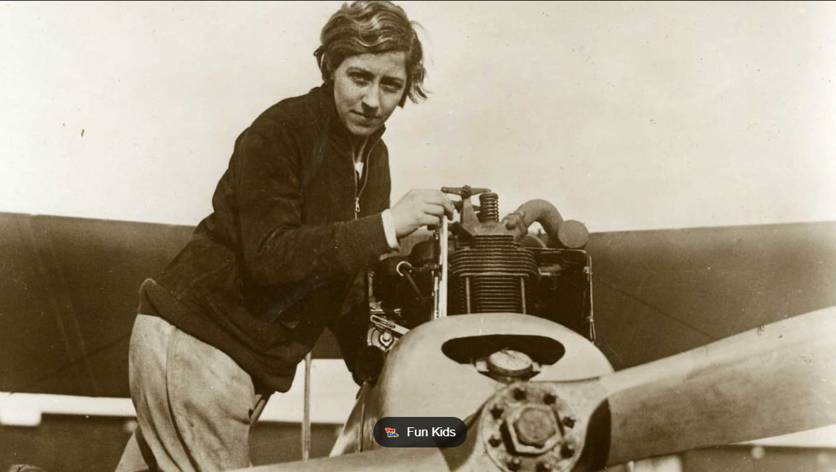

1. Commercial airlines often find it cheaper to park their ***aircraft（飞机；航空器；飞行器）*** at a storage facility than at an airport. (复数？)





1. Reading has become the ***fashionable（（尤指短期内）时髦的，流行的）*** educational activity for summer months with schools and libraries running reading challenges.
2. He said a few ***meaningless（无目的的；无意义的；无价值的；不重要的）*** words to his hostess and looked around the room.
3. Their tips provide guidance to anyone looking to set up a smart and ***functional（实用的）*** workspace at home.
4. This store offers a wide range of clothing, shoes, and ***accessories（装饰物，小配件（如手袋、皮带、珠宝等））*** for men, women, and children. （一般用复数）

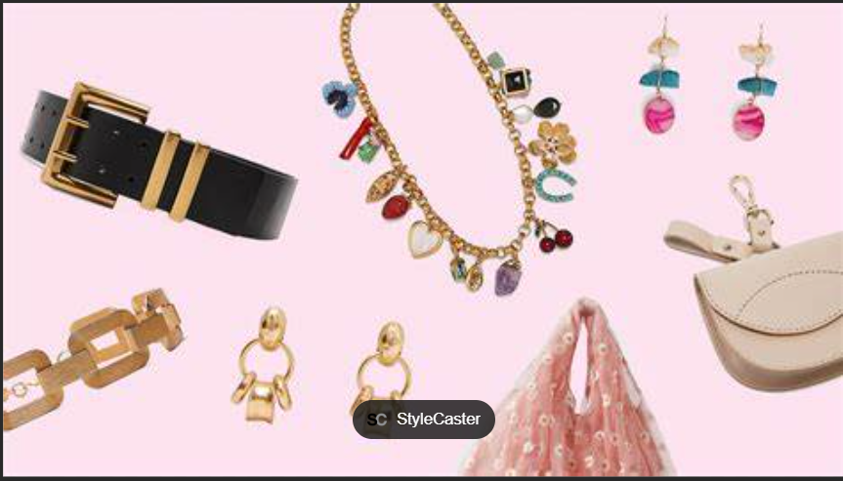

1. ***Accessories（配件；附件）*** such as a carrying case and a ***battery recharger*** are free with the purchase of a cell phone. （一般用复数）

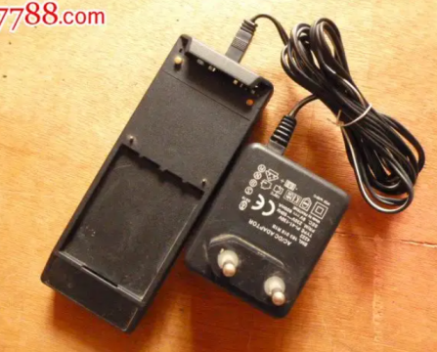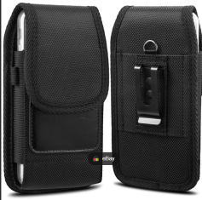

1. They specialize in the supply of sports ***apparel（衣服）*** such as sweatshirts (长袖运动衫) and baseball caps to retail markets. （读音）[əˈpærəl]

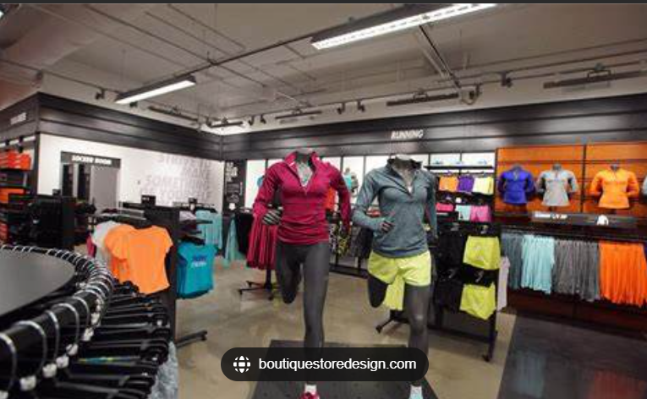

1. There are many brave and admirable social workers doing ***unremarked（不受注意的；末被注意的）*** work across the nation.
2. The world's largest iceberg would possibly crash into an island ***populated（居住于）*** by penguins and seals.

populate

|  |  |
| --- | --- |
| ① (VERB) （大批地）居住于，生活于，栖居于 If an area is populated by certain people or animals, those people or animals live there, often in large numbers.  (=inhabit ) | (figurative)the amazing characters that populate her novels  常见于她小说中的令人惊叹的人物  a heavily/densely/sparsely/thinly populated country  人口密集 / 稠密 / 稀疏 / 稀少的国家  The island is populated largely by sheep.  这个岛的主要生物是绵羊。 |
| to move people or animals to an area to live there 迁移；移居；殖民于 | The French began to populate the island in the 15th century.  法国人于15世纪开始迁移到这个岛。 |
| ③ (VERB) 在…中占有位置；占据 The people or characters who populate an area of public life or a piece of entertainment are the people or characters in it. | ● ...the diligent and discreet technocrats who populate the upper reaches of French power.  占据法国政权上层的勤勉、审慎的技术专家型官员  ● ...the sort of low-life characters who populate the film.  电影里那种来自下层社会的人物 |

1. Evidence is needed to prove that the word has been used in a variety of different sources before it can be considered for ***inclusion（包含；包括）*** in one of the dictionaries.

inclusion [opp. Exclusion]

[不可数名词] the fact of including sb/sth; the fact of being included （被）包括，包含

[可数名词] a person or thing that is included 被包括的人（或事物）

His inclusion in the team is in doubt. 他是否能被选入这个队还未定案。

There were some surprising inclusions in the list. 名单中包括一些意想不到的人。

...a confident performance which justified his inclusion in the team.

...the inclusion of the term 'couplehood' in a Dictionary of New Words (夫妻之道)这一词条被收入

造句：_________________

1. She is planning to travel to ***distinctly（十分）*** different destinations in pursuit of happiness and vision.
2. I ***distinctly（清楚地；明显地）*** remember asking him not to tell her about the new sales figures.
3. The works came to light during the 1950s, when they were ***catalogued（为⋯编目录；把⋯列人目录中）*** in the museum's collection.
4. She uses an online ***catalogue（目录）*** to search for items by price or country, instead of the hard copies traditionally taken to auctions（拍卖会）

(讲练习)

1. Focused on artwork inspired by nature, this exhibition is ***curated（策划组织（展览、表演、音乐会等））*** by tour high school students.

● The Hayward exhibition 海沃德艺术展 has been curated by the artist Bernard Luthi.

1. Milly is the most serious person I know – her stories are always completely ***devoid（毫无某物：完全没有某物）*** of humor.

The letter was devoid of warmth and feeling. 这封信既无热情又无感情。

● I have never looked on a face that was so devoid of feeling... 面无表情

● The skies are virtually devoid of birdlife. 天空中几乎没有任何鸟的踪迹。

造句：

1. Studies in this area investigate how objects or messages can arouse ***affective（情感的）*** reactions.

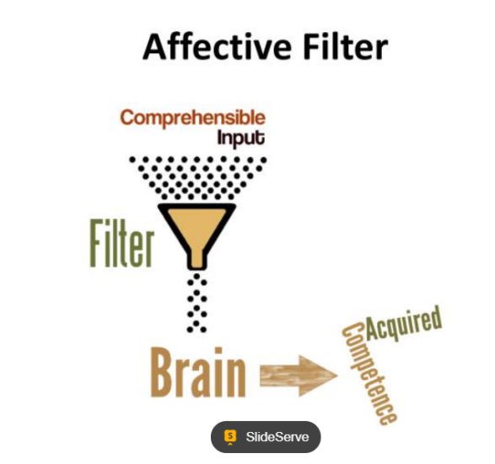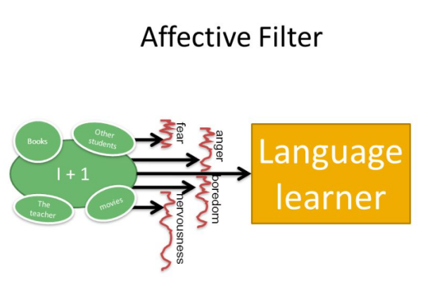



1. She signed the book and ***inscribed（（尤指在石头或硬币表面）雕刻，印制，题写）*** the words "with grateful thanks" on it.

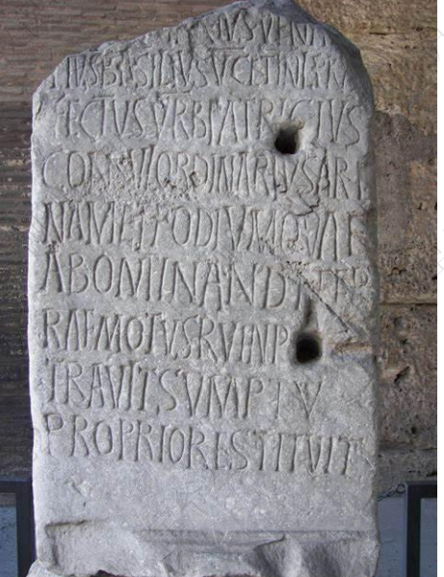

② (VERB) 题写;题献;题赠 ● The book is inscribed: To John Arlott from Laurie Lee. 书的题赠是：献给约翰·阿洛特——劳丽·李。

|  |  |
| --- | --- |
| indescribable | adj. 难以形容的；莫名其妙的；不能用语言表达的 |
| scribe /skraɪb/ | n. 抄写员；作家 vt. 写下，记下 |
| scribble /'skrɪbl/ | n. 潦草的字；胡写乱画的东西；涂鸦  v. 潦草（或匆忙）地写；乱写，乱涂（画） |
| script | n. 脚本；手迹  vt. 把…改编为剧本  vi. 写电影脚本 |
| ascribe | 归因于；归咎于  It 's wrong to ~ all that have happened simply to the war. 把发生的一切归咎于战争是错误的。 |
| circumscribe | A man should not ~ his activity by any rigid rules. 人不该被任何严格的规则限制自己的行动。 |
| circumscription | n. 界限；划界 |
| conscribe | 征召入伍 |
| conscript/scription | conscript/scription |
| prescribe | V. 规定；开处方 |
| prescription | n. 处方，药方；指示，法规 |
| nonprescription | adj. 非处方的；未经医生处方可以买到的 |
| subscribe | vt. 签署；捐助；订阅  My main reason for ~ing to Fashion is to keep pace with fashion. |
| subscriber | 订户；签署者；捐献者 |
| transcribe | 转录；抄写 She is ~ing his dictation. 她正在记录他的口述。 |

1. These fragments provide ***tangible（确凿的；明显的；实在）*** evidence tor how the city has changed since the 18th century.

非物质文化遗产 intangible cultural heritage

|  |  |
| --- | --- |
| [常用于名词前] that can be clearly seen to exist 有形的；实际的；真实的 | *tangible benefits/improvements/results,* etc.  实际的好处、改进、效果等  tangible assets (= a company's buildings, machinery, etc.) 有形资产 |
| that you can touch and feel 可触摸的；可触知的；可感知的 （反：intangible） | The tension between them was almost tangible .  他们之间的紧张关系几乎让人都感觉得出来。 |

● There should be some tangible evidence that the economy is starting to recover...

应该有明显迹象表明经济开始复苏了。

● The relief was almost tangible. 这种解脱几乎可以感觉得到。

1. ***fibre 纤维***
2. His sporting and literary interests ***coalesced(联合；合并)*** admirably in his writing about climbing. [ˌkəʊəˈles]
3. You'd better put a ***stitch(（缝纫中的）一针；缝)*** in the corner of the pocket to keep it in place.
4. Human beings have a need for both independence and ***connectedness(相互联系；社会关系).***
5. Her knowledge and experience would make her a ***priceless(极其贵重的；极其重要的)*** asset to the team.
6. The project includes the ***conservation(保存；保护；节约)*** of 200 paintings, 15,000 books and quantities of furniture, ceramics and textiles.
7. China is one of the few places in the world where the elephant population is growing thanks to extensive ***conservation(（动植物、森林等的）保护)*** efforts.

|  |  |
| --- | --- |
| ① (N-UNCOUNT) (对环境的)保护 Conservation is saving and protecting the environment. | a four-nation regional meeting on elephant conservation  tree-planting and other conservation projects |
| ② (N-UNCOUNT) (对文物或艺术品的) 保护 | the conservation and rebinding of 保护并重新装订 |
| ③ (N-UNCOUNT) 节约;防止浪费 The conservation of a supply of something is the careful use of it so that it lasts for a long time. | ..projects aimed at promoting energy conservation. 旨在促进节约能源的计划  .rules concerning the conservation of fishery resources. 有关保护渔业资源的规定 |

[ ] to be interested in wildlife conservation

[ ] to encourage the conservation of water/fuel

1. Objects will be accepted and ***accessioned(将(图书馆、博物馆等的新书、新展品）登记入册)*** into the museum's collections when these conditions are met.
2. It is ***incumbent（有责任的；有义务的；必须履行的）*** upon parents to control what their children watch on TV. |ɪnˈkʌmbənt|

|  |  |
| --- | --- |
| ① a person who has an official position 在职者；现任者 | the present incumbent of the White House 现任美国总统  ● In general, incumbents have a 94 per cent chance of being reelected. 现任官员 |
| 现任的 | the incumbent president |
| ② (ADJ) 成为责任的;义不容辞的;必须履行的 If it is incumbent upon you to do something, it is your duty or responsibility to do it. | ● It is incumbent upon all of us to make an extra effort. 我们所有人都必须加倍努力。  It was incumbent on them to attend.  他们必须出席。 |

造句：_______________

1. These oral historians were the ***guardians（维护者；保卫者）*** of traditional values and the teachers of lessons about the natural world.
2. The girl's parents or ***guardians（监护人）*** must give their consent before she has the operation. consent 同意，许可 informed consent 知情同意

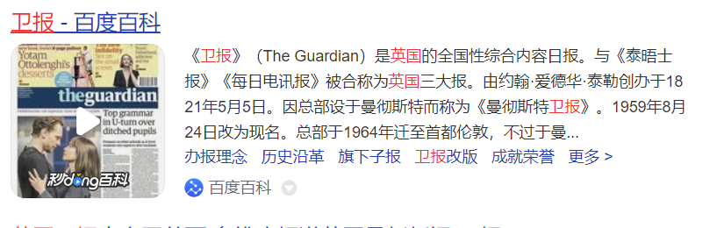

*The Guardian, Times, The Daily Telegraph 《卫报》《泰晤士报》《每日电讯报》*

(讲练习)

1. We've put the best wedding photos into an ***album（（收存服片、邮聚等的）簿，册）*** - do you want to see them?
2. The singer talked about the inspiration behind the creation of each track from his newly released ***album（（歌曲或音乐的）专辑）***.

*Family Album USA*



1. The company has been growing ***organically（自然地；持续地）*** over the past few years.

(formal) happening in a slow and natural way, rather than suddenly 逐渐的；演进的；自然的

the organic growth of foreign markets 国外市场的逐步发展

1. There is firm evidence that ***organically（不使用化肥地；有机地；绿色地）*** grown crops are healthier to eat than conventional ones.
2. The higher cost of providing full services to a ***scattered（分散的；稀疏的）*** community cannot be ignored.

scatter

|  |  |
| --- | --- |
| [动词 + 名词短语] ~ sth (on/over/around sth) | ~ sth (with sth) to throw or drop things in different directions so that they cover an area of ground 撒；撒播 | Scatter the grass seed over the lawn. 把草籽撒到草坪上。  Scatter the lawn with grass seed. 在草坪上撒上草籽。  They scattered his ashes at sea. 他们把他的骨灰撒向大海。 |
| to move or to make people or animals move very quickly in different directions (使)(人群)分散;(使)散布在各处;(使)散开 (= disperse) | At the first gunshot, the crowd ***scattered***.  The explosion ***scattered a flock of birds*** roosting (栖息) in the trees. |
|  |  |

(N-SING) (散放的)摊，堆 A scatter of things is a number of them spread over an area in an irregular way.

[ ] They've been scattering toys everywhere.

[ ] After dinner, everyone scattered.

[ ] The cavalry (骑兵) scattered them and chased them off the field.

[ ] On the table was a pile of books and a scatter of papers.

造句：__________________________

1. This year's ***festivities（庆祝活动；庆典）*** included fireworks light shows and a live concert in King International Stadium.
2. It is the ***uniqueness（不同寻常;独特；独一无二）*** of her painting style for which she has been remembered over the past decades.
3. ***thread 缝衣服的线***

|  |  |
| --- | --- |
| [不可数名词, 可数名词] a thin string of cotton, wool, silk, etc. used for sewing or making cloth （棉、毛、丝等的）线 | a needle and thread 针线  a robe embroidered with gold thread 用金线绣的长袍  the delicate threads of a spider's web 蜘蛛网的纤丝 |
| [可数名词] an idea or a feature that is part of sth greater; an idea that connects the different parts of sth 线索；脉络；思绪；思路；贯穿的主线 | A common thread runs through these discussions. 这些讨论都贯穿着一条共同的主线。  The author skilfully draws together the different threads of the plot. 作者娴熟地把情节的各种线索串联在一起。  I lost the thread of the argument (= I could no longer follow it) . 我再跟不上这论证的思路了。 |
| [可数名词] ~ (of sth) a long thin line of sth 线状物；细细的一条 | A thread of light emerged from the keyhole.  从锁眼里透出一丝光亮。 |

[ ] This time I'll do it properly with a needle and thread.

[ ] ...a tiny Nepalese hat embroidered with golden threads.

[ ] The thread running through many of these proposals was the theme of individual power and opportunity.

[ ] All religions are united by the common threads of fighting evil and helping others...

1. Companies should focus on customer experiences and strive to improve those experiences through constant ***iteration（重复）***.

reiterate |riˈɪtəreɪt|

(formal) to repeat sth that you have already said, especially to emphasize it 反复地说；重申

to reiterate an argument/a demand/an offer 重申论点；重复一项要求 / 建议

Let me reiterate that we are fully committed to this policy. 我再说一遍

He reiterated his opposition to the creation of a central bank...

1. Upon hearing these words, she began walking slowly but ***purposefully（有目的地；有决心地；果断地）*** toward the bridge.
2. Every member of the family can now ***tuck away（将某物存起来或藏起来）*** either £9 or £18 a month in one of these savings plans.
3. That's why there are tens of thousands of start-ups ***in existence（存在）*** today.
4. ***It is incumbent upon（做某事是某人的职务（责任））*** all users of this equipment to familiarize themselves with the safety procedure.
5. Stephen Hawking, who is known for his groundbreaking work with black holes and relativity, ***passed away（去世；离世）*** at the age of 76.